Renewal Addendum – Managed Platform & Application Services (2026 Term)
Prepared by CANDID Solutions for LendingClub Corporation
Effective December 1, 2025 – December 31, 2026

PURPOSE & RENEWAL TERM
This Renewal Addendum is made pursuant to Section 9 (“Term of Agreement”) of the 2025 original Agreement between CANDID Solutions, Inc. and LendingClub Corporation. The parties agree to renew the Agreement for an additional one-year term (“Renewal Term”), commencing December 1, 2025 and expiring December 31, 2026.
RENEWAL AND PAYMENT TERMS
LendingClub shall pay CANDID Solutions $140,000 USD for the 2026 calendar year, payable in quarterly installments of $35,000 each, due in advance. An 8 percent prepayment discount (reducing the total to $128,800 USD) applies if the full annual amount is paid upfront.
Written notice of non-renewal must be received at least 30 days prior to the end of any quarter; otherwise, this Agreement will automatically renew for the following quarter under identical terms. Quarterly fees include all platform services, hosting, support, and maintenance. Printing and shipping costs for physical marketing materials are excluded and will be billed separately. Please refer to the Pricing Summary section of this Renewal Agreement.
MARKETING AND MATERIAL MANAGEMENT
CANDID Solutions will take ownership all marketing assets, logistics, and fulfillment processes related to the LendingClub program. This includes design, production coordination, and quality control of printed materials (QR-code signage, display kits, patient packets, table tents, and other collateral). Oversight covers vendor coordination, shipment tracking, and inventory maintenance to ensure availability. All printing, production, and shipping expenses shall be invoiced separately at actual cost, with additional coordination fees applied.
SCOPE & DELIVERABLES
- Cloud hosting, patching, and 99% uptime assurance
- Firewall and API security management
- SSL renewal, OWASP compliance, and data integrity monitoring
- Managed DNS/CDN optimization and domain registration
- User onboarding/offboarding
- Automated merchant communications and SMS integrations
- QR code tracking and marketing material coordination
- Compliance management under HIPAA, GDPR, and PCI DSS frameworks

COMPLIANCE & CERTIFICATIONS SUMMARY
The Patient Notify application is built on the Zoho Creator platform, developed by CANDID Solutions and maintained by Zoho Corporation (California, USA). Zoho Corporation holds internationally recognized certifications in information security, privacy, and business continuity. Within this certified environment, CANDID Solutions administers and manages the system to ensure compliance with Zoho’s standards:
Core Frameworks & Certifications
- ISO/IEC 27001 – Information Security Management
(Certificate IS 642819, valid through Aug 21, 2028 — applies to all Zoho Cloud Services)
- ISO/IEC 27701 – Privacy Information Management (GDPR/CCPA)
(Certificate PM 732705, valid through Aug 21, 2028 — applies to all Zoho Cloud Services)
- ISO/IEC 27017 & 27018 – Cloud Security and PII Protection
(Certificates CLOUD 714132 and PII 714133, valid through Aug 21, 2028 — applies to all Zoho Cloud Services)
- ISO/IEC 20000-1 – IT Service Management
(Certificate 0116286, valid through Jul 29, 2027 — Zoho NOC and Data Center Operations)
- ISO 9001 – Quality Management System
(Certificate FS 724104, valid through Feb 2, 2026 — Zoho / ManageEngine Services)
- ISO 22301 – Business Continuity Management
(Certificate BCMS 689185, valid through Nov 20, 2026 — Zoho Global Data Centers, HR, Legal, and Admin Functions)
- SOC 1 & SOC 2 Type II (+ HIPAA) – Security and Financial Reporting Controls
(Valid 2025–2026 — All Cloud and On-Prem Zoho Products)
- PCI DSS (SAQ-D) – Payment Card Industry Data Security Standard
(Valid through Oct 14, 2026 — Zoho Finance Suite)
- Cyber Essentials Plus – UK Cybersecurity Standard
(Valid through Sep 19, 2026 — Zoho EU Data Centers)
- HIPAA – Health Information Privacy and Security
(Aligned with U.S. HHS standards for PHI and PII data handling)
- GDPR & CCPA – Global Data Protection Regulations
(Ongoing — applies to all customer and patient data processed through the platform)

PRICING SUMMARY
Description / Category | Inclusions / Description | Cost | Payment Terms & Notes
LendingClub Platform Renewal (2026) | Renewal of all modules, integrations, hosting infrastructure, and API access through Dec 2026. Includes LendingClub-specific configurations, enhancements, and SLA coverage. | $140,000 | $35,000 per quarter in advance or $128,800 total if prepaid annually (8% discount).
Managed Hosting & Maintenance | Cloud hosting, scaling, server optimization, SSL renewals, patching, OWASP compliance. | Included | Continuous management by CANDID.
Security & Compliance Management | Firewall, intrusion detection, vulnerability scanning, monthly reports. | Included | 24×7 monitoring and oversight.
DNS/CDN Management | DNS and CDN optimization, domain renewals (2 domains). | Included | Zoho DNS with redundancy.
SMS Messaging (500k) | Twilio-based patient and merchant messaging. | Included | Additional 250k messages = $3,000.
User Access Control | Provisioning for all LendingClub client locations. | Included | Managed by CANDID.
Marketing Materials / Re-Order Platform | Design, QR generation, merchant tracking, automation. | Billed Separately | Actual cost per order.
Dashboard & Reporting | New real-time reporting dashboard pending key metrics discussion between Candid and LendingClub. Current reporting continues until launch of new dashboard. | Included | Enhancements absorbed.
Mailing Automation & App Support | Follow-up workflows and notifications. | Included | Monitored by CANDID.
QR Code Management & Link Tracking | Real-time tracking and analytics for active QR codes. | Included | Ongoing optimization.
Platform Support & Maintenance (SLA) | 24×7 monitoring and issue resolution. | Included | CANDID SLA applies.
Total Annual Fee (CANDID) | Fixed all-inclusive pricing for the above services. | $140,000 | Quarterly or Annual (8% discount if prepaid).

MARKETING MATERIALS – PRINTING & SHIPPING DETAILS
The following information outlines typical production and fulfillment costs for LendingClub-branded marketing materials. These costs are billed separately from the $140,000 platform renewal fee and invoiced at actual cost at the time of each order request. CANDID manages all design, coordination, vendor communication, and logistics as part of the platform scope under this Agreement.
Typical Printed Materials and Estimated Costs
ITEM | DESCRIPTION | APPROXIMATE COST
Full-size 9x12.5-in Packet | LendingClub Branded Envelope for UPS Delivery | $13.00
*Larger Welcome Letter | New merchant welcome communications letter
*Table Tents (set of 2) | Dual-sided display tents for patient areas | Included
*Labels (9 count, 3×3) | Printed QR code or branding labels | Included
Cardboard Carrier Logo | Branded LendingClub Logo on outside of mailer pack | Included
Small-size 6×8-in Packet (alternative packet) | LendingClub Branded Envelope for UPS Delivery | $11.00
Smaller Welcome Letter (5.5x7.5) | New merchant welcome communications letter | Included
15 3×3 Stickers | Additional branded labels or collateral | Included
Cardboard Carrier Logo | Branded LendingClub Logo on outside of mailer pack | Included

*Refer to the end of this agreement for pictures of the Patient Notify Marketing Materials listed above..
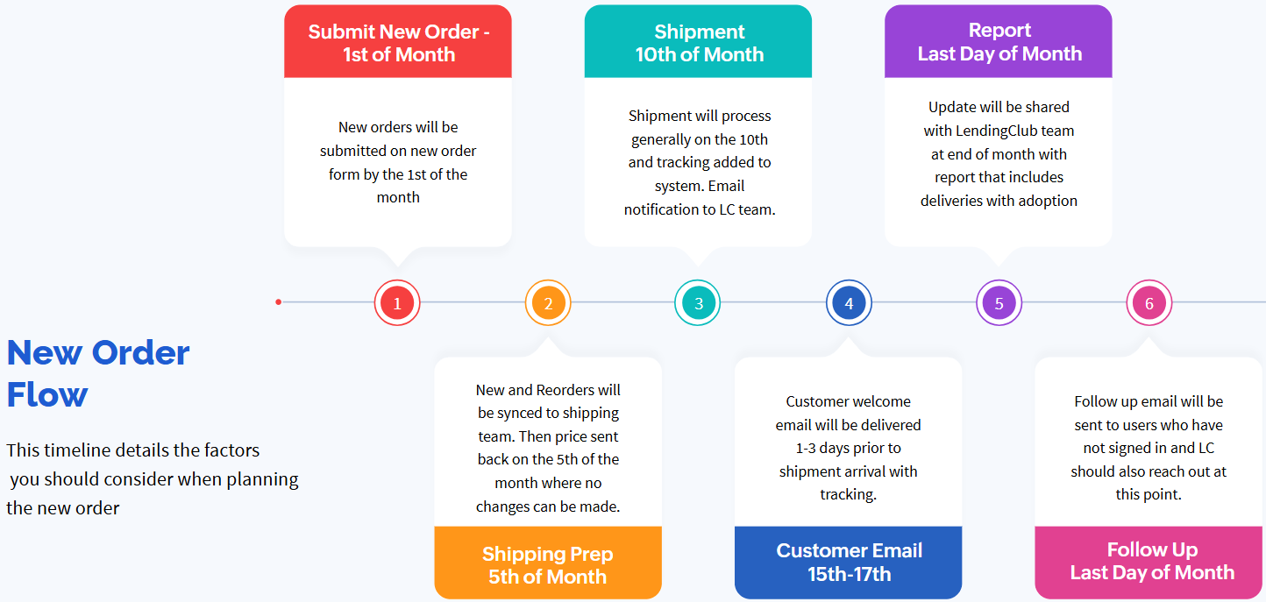
Shipping Estimates Note: Typical shipping rates range from $7.86–$10.09 per order, depending on destination and weight. Please note that during peak shipping seasons, carrier surcharges may apply — currently averaging $0.40 per package, increasing to $0.60 during the Thanksgiving period.

SUMMARY STATEMENT FOR RENEWAL
The $140,000 renewal reflects CANDID’s continued commitment to providing LendingClub with a fully managed, enterprise-grade platform that unifies hosting, infrastructure, security, compliance, DNS management, reporting, marketing materials, shipping and support under a single SLA. Through its Zoho cloud architecture, CANDID delivers exceptional reliability, speed, and scalability. All services operate within the security framework established by SOC 2, HIPAA, GDPR, and ISO 27001 standards, ensuring full regulatory compliance and continuous data protection. This renewal sustains a proven environment built and optimized exclusively for LendingClub — minimizing vendor complexity, strengthening operational continuity, and preserving a predictable, fixed-cost structure under one trusted partner.

SIGNATURES
LendingClub Corporation
By: _____________________________
Name: __________________________
Title: __________________________
Date: __________________________
CANDID Solutions, Inc.
By: _____________________________
Name: __________________________
Title: __________________________
Date: __________________________

Marketing Material Images on next page

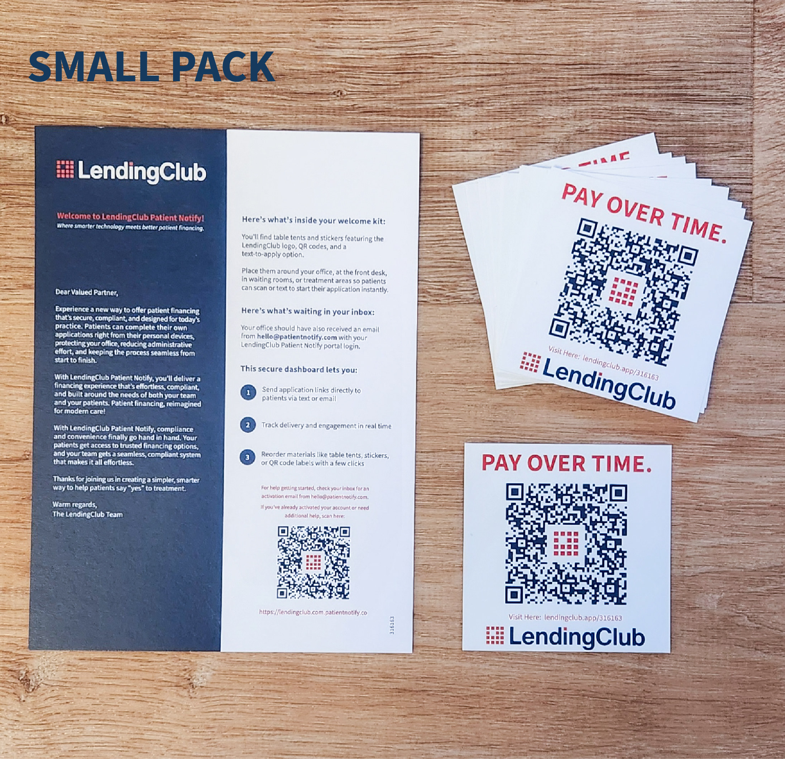
PATIENT NOTIFY MARKETING MATERIALS
